**Student Role**

The academic week starts on Monday. Students must complete all required reading and watch all required videos before class on Thursday. Students should start homework before Thursday, so they can ask questions and get help from the instructor. Students must complete and turn in all homework before the following Monday.

**Instructor Role**

Class Meetings

* Students ask questions about the content reviewed that week
* Instructor asks questions to ensure and enforce understanding
  + Questions should hit multiple levels of Bloom’s Taxonomy
  + 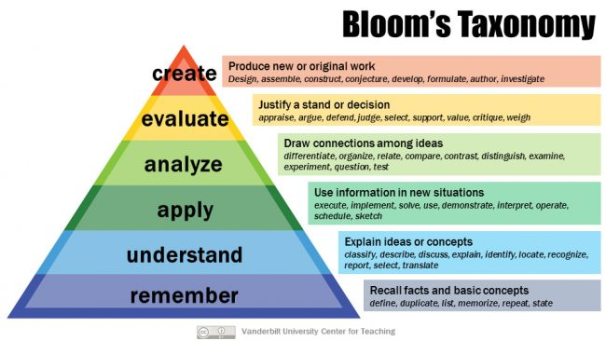
* Brief recaps on subjects the instructor deems necessary
* Hands-on activities
* Help with homework if time permits